The George Washington University

School of Business

**Queens of Soul**

Team Members:

Evelyn Adebayo

Destiny Henderson

Jhurney Hairston

ISTM 6205

Professor Bradley

April 22, 2024

# TABLE OF CONTENTS

Strategy 3

Scope and Structure 3

Skeleton 5

Surface 7

Implementation and Reflection 10

# I. Strategy

The purpose of the website is to highlight and showcase authentic soul food cuisine offered by Queens of Soul. The website will provide essential information such as the menu, our location, about the history of the restaurant, and where the restaurant is located. The goal of the website is to attract new customers by focusing on the restaurant’s special menu items, the chefs, and having a seamless user-friendly experience for patrons.

The primary audience of the restaurant’s website will be food enthusiasts and those who enjoy the taste of soul food cuisine. This could include local residents looking for a place to eat or tourists looking for something to explore in the area. Secondary audiences could be event planners looking to cater an event, food bloggers or content creators who want to use the restaurant for content, and individuals who are interested in working at Queens of Soul.

# 

# II. Scope and Structure

Queens of Soul is a soul food restaurant that wants to exhibit and truly showcase our special, unique menu and food excellence to the world. It’s essential that our site has a simple user interface that allows existing and new customers to be able to navigate through our site simply and be able to acquire the information they are looking for without hassle, ranging from our location to our different menu offerings, and to who we are, etc.

Our site will also have a form available on our contact page so that customers can make inquiries and to help make bookings and reservations etc. These are unnegotiable features that our site must and will include to fulfill its function of showcasing and advertising our great soul food cuisine, as well as being a bridge to help us hear from and communicate with potential guests.

# 

# 

# 

# 

# III. Skeleton

The following sketches depict our vision for the websites look and experience

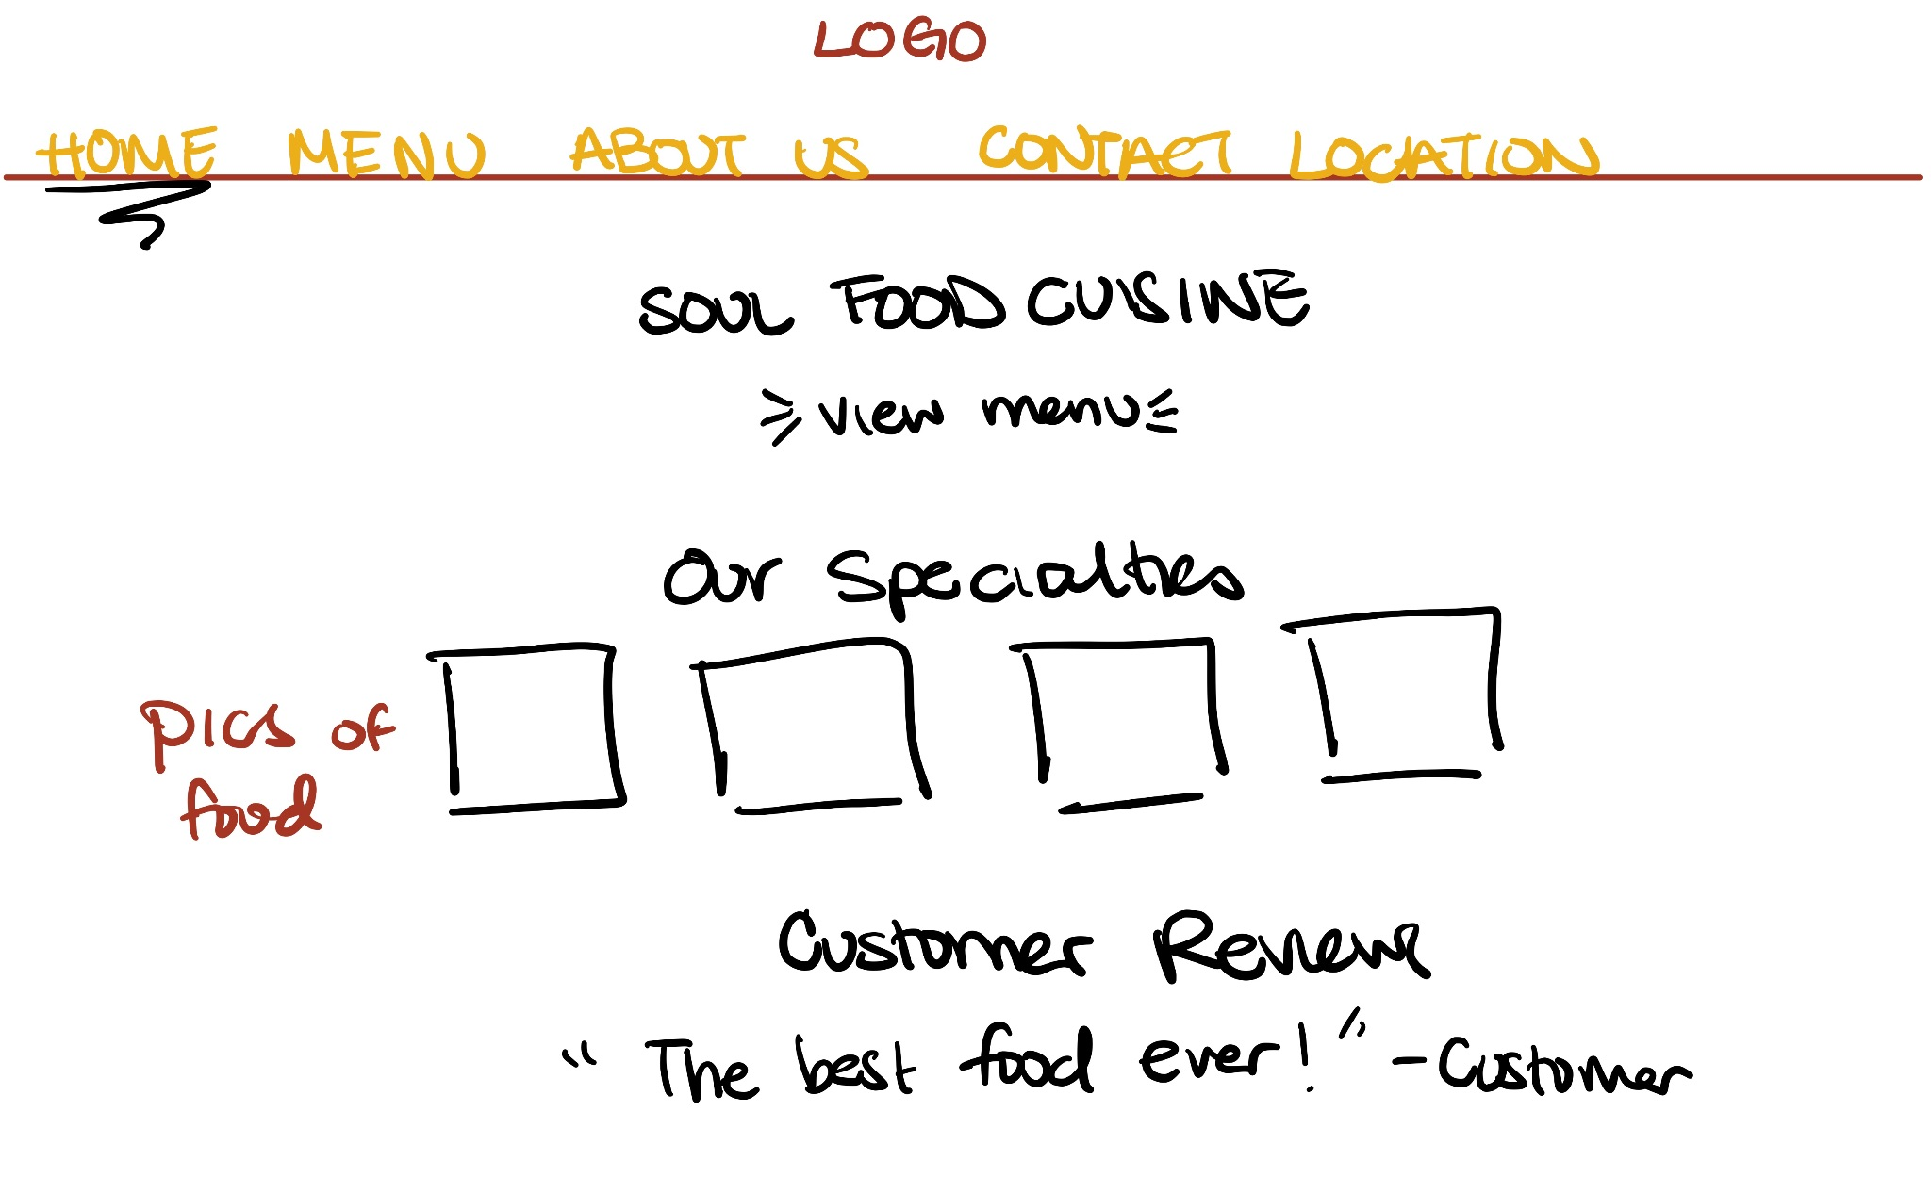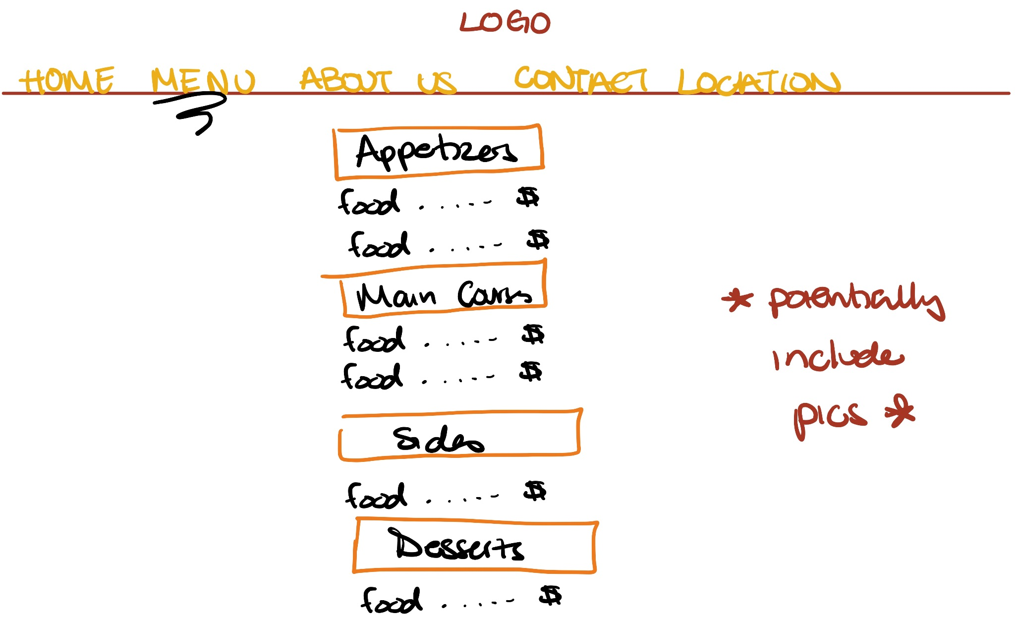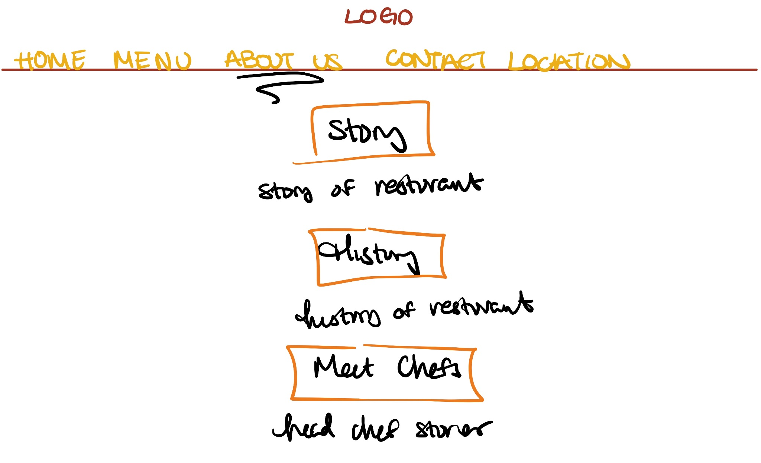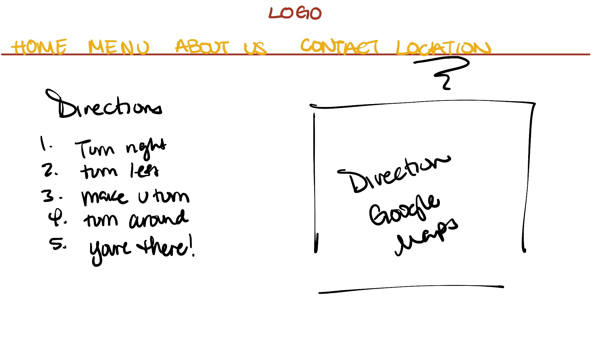

# IV. Surface

The surface of our page has direct links to the specific pages that guests can navigate to. Our website is certainly manageable to use and is known for website feasibility. The options on the navigation tab are: Home, Menu, About Us, Contact Us, and Location. These tabs preview a quick synopsis of the page and the many details that the page entails.

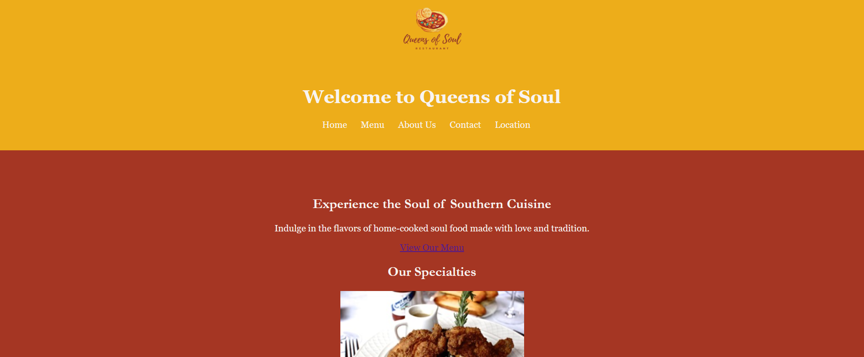

The Home page features a striking presentation of our restaurant. Offering a warm welcome and showcases images of Queens of Souls’ mouthwatering platters.

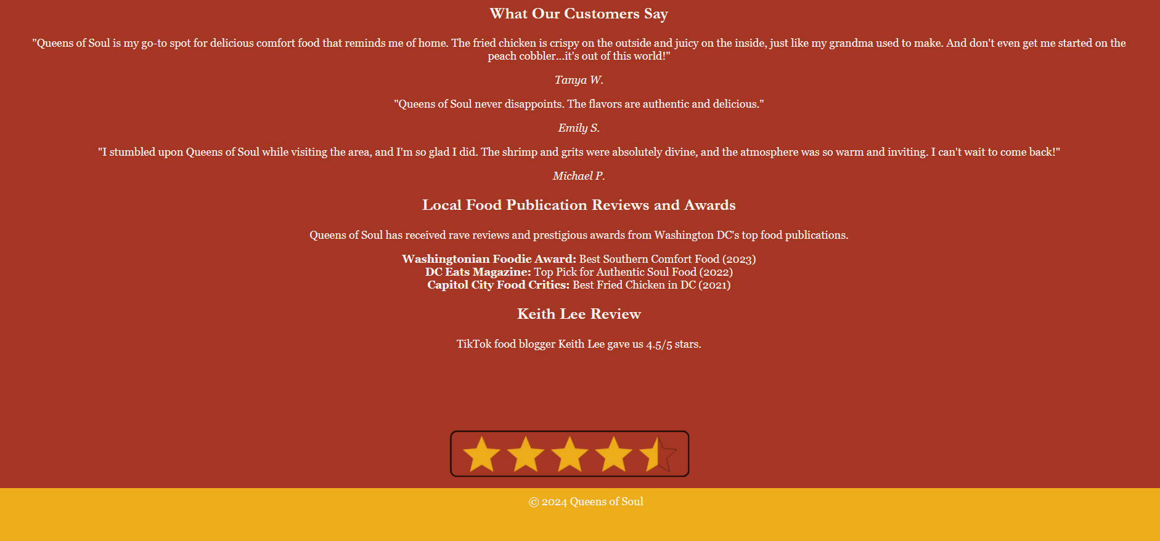

The About page is where guests learn who the entrepreneurs and women business owners are. This page also includes pictures and the mission of our restaurant.

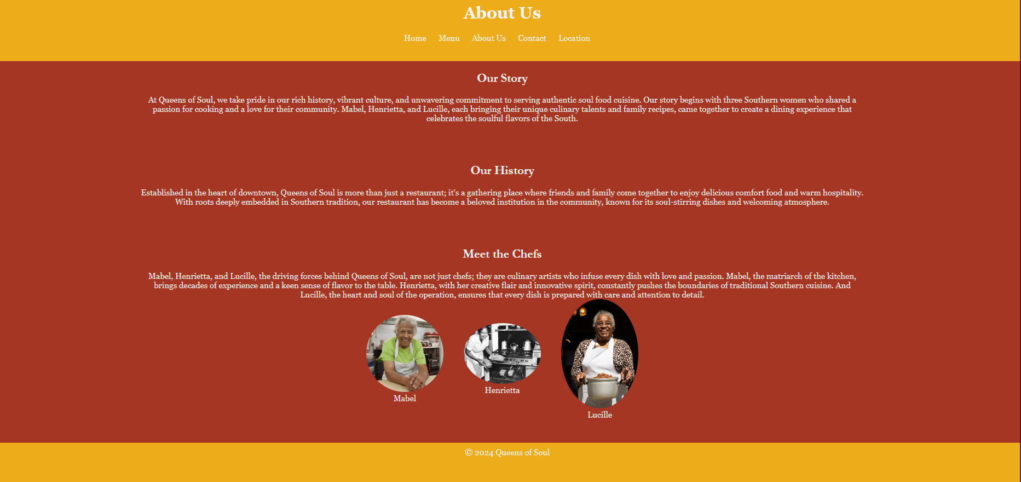

The Menu page is a sensory depiction of our menu favorites and how we can showcase our dinner delights. These mouthwatering images and descriptions will put your taste buds in a trance! Let your mind help you unconsciously pick our best menu items.

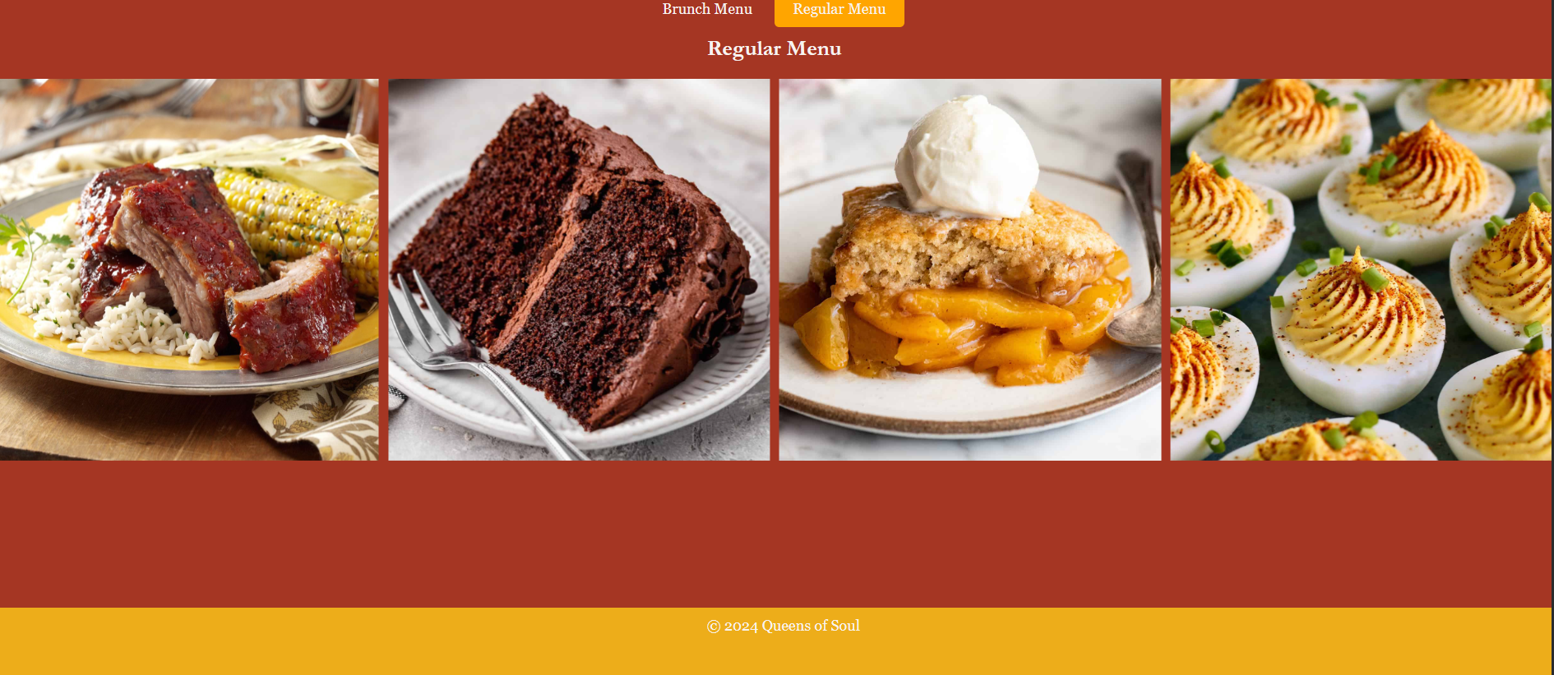

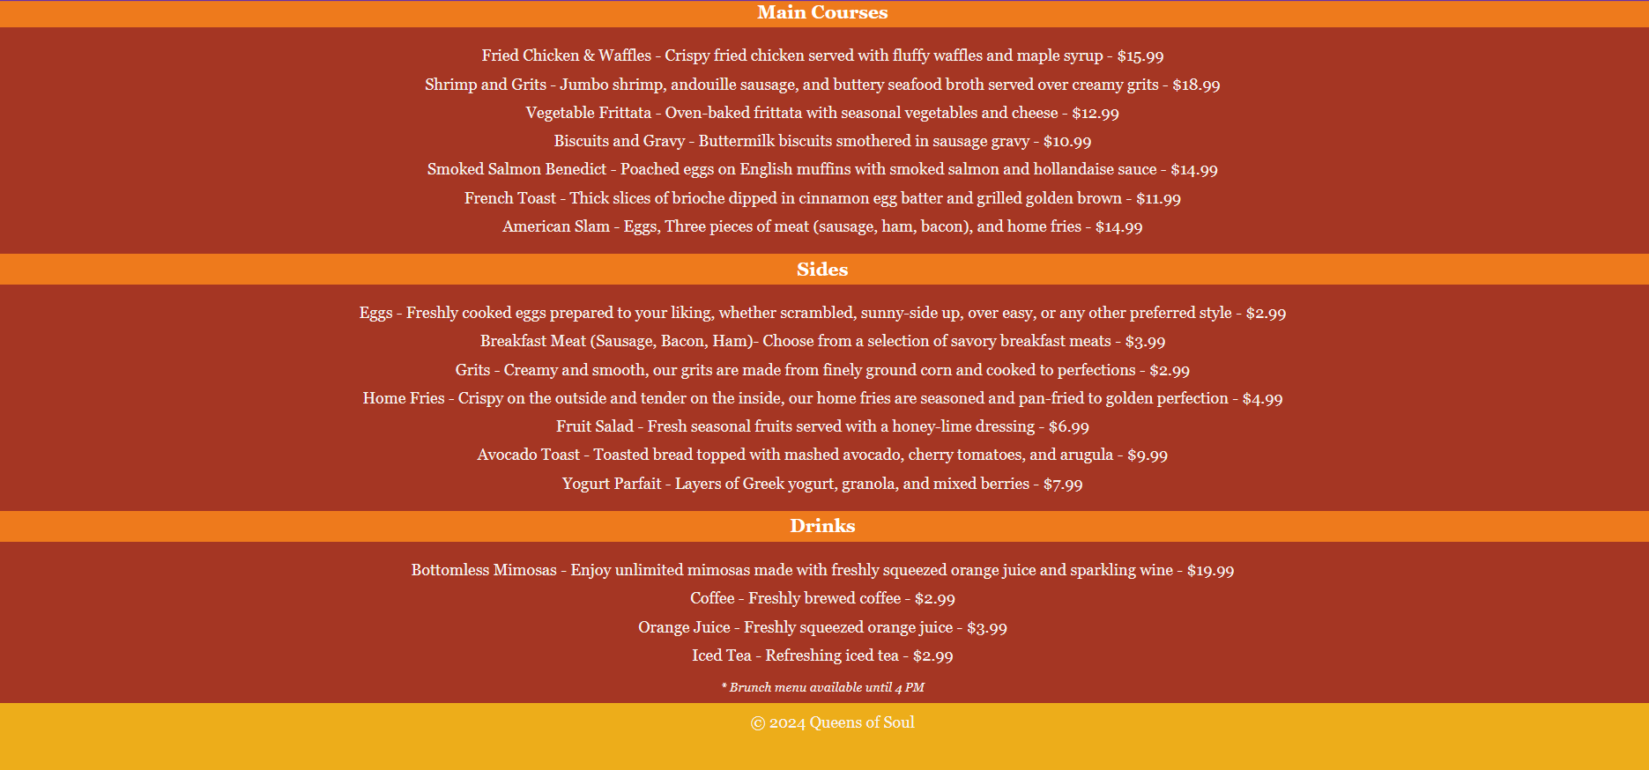

On the Contact Us page, guests have the opportunity to have a connection with our team. They have the option to leave feedback or reviews.

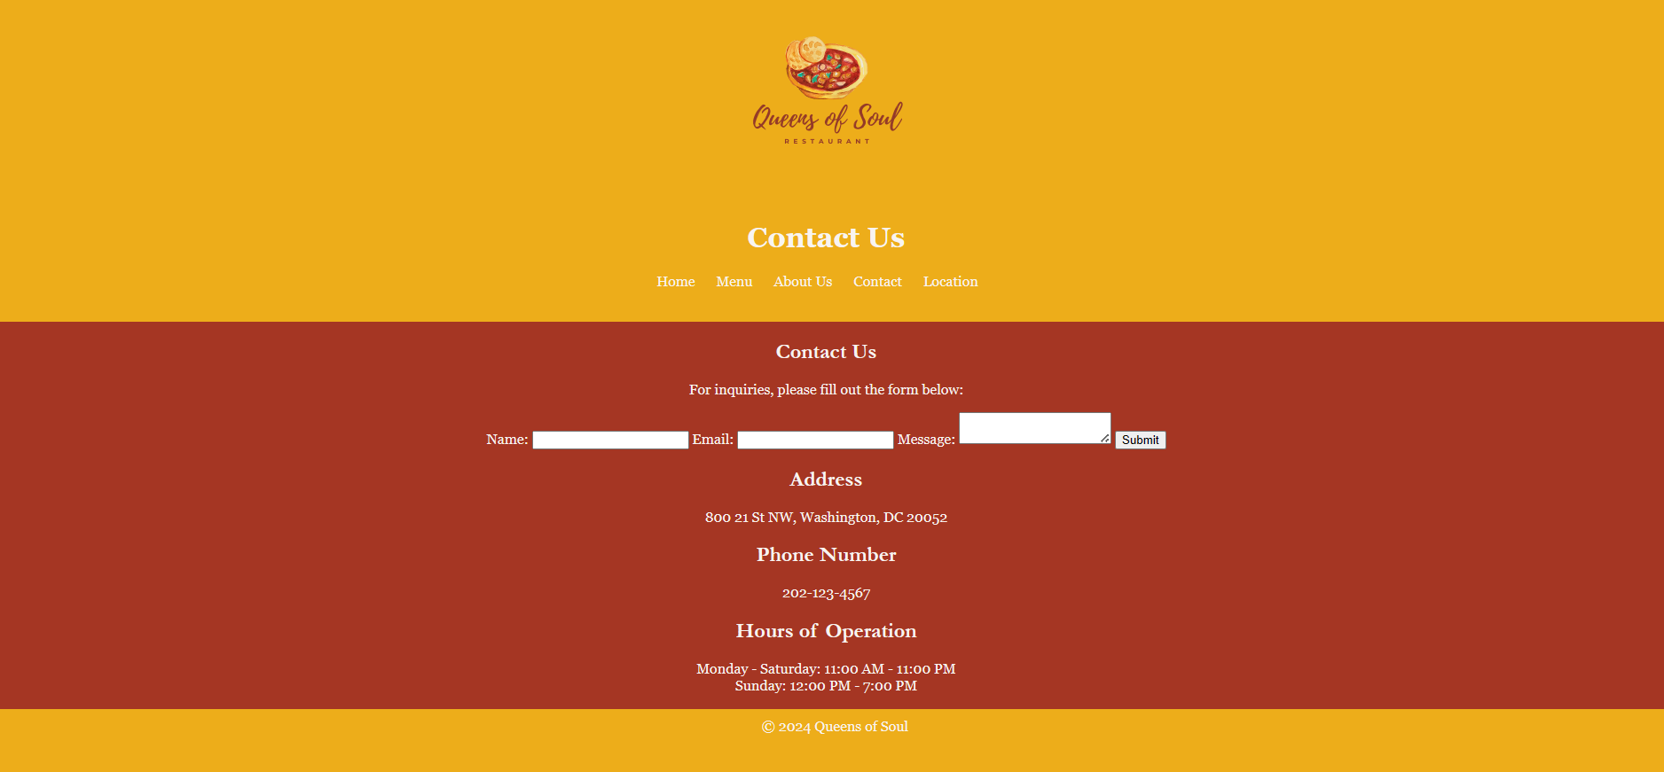

The Location page serves as a virtual map, which guides our guests to our #1 location. There are geographical coordinates of exactly where this location is. This makes finding our restaurant easier for local and international travelers.

# 

# V. Implementation and Reflection

Queens of Soul has become a beloved destination for the patrons in the district area and our cuisine has served hundreds of thousands of guests. We currently have two main menus that focus on offering brunch and dinner services to DC natives and tourists who are visiting the District of Columbia. Since opening up our doors, we have established rapport with our customers and accepted a lot of feedback from our guests. We are astonished to introduce our plans to utilize food delivery services and mobile pick-up orders to help alleviate the heavy foot traffic we receive during business hours.

Our online service will revolutionize the Queens of Soul experience, offering customers a seamless way to enjoy our menu favorites without physically being in our establishment.. Through our intuitive online ordering platform, guests can peruse our menus at their leisure, place orders easily, and complete transactions securely from the comfort of their own devices. Additionally, our partnership with Uber, Doordash, and FlyBike will bring our signature dishes directly to the doorsteps of customers within our delivery radius, ensuring that the Queens of Soul experience can be savored wherever they may be. For those on the move or preferring a quick stop, our mobile pick-up option allows orders to be placed in advance. This will give the guest an option to skip the long waits, and their food will be in the waiting area upon arrival. These innovations not only cater to the evolving needs of our clientele but also underscore our commitment to enhancing accessibility and convenience while maintaining exceptional quality for Queens of Soul.

Also, since DC is reputable for its popular brunch, we will offer bookings for tables/sections during brunch hours. The section will come with a bottle of alcohol and a bottle of champagne. Brunch menu items will still remain at the same price.

Reflecting on the overall project, we think that the biggest lesson learned was to remain patient and continue to take my time with the lines of code. Since this was my group's first time building a website, we had to continuously look over chapters we’ve covered during the course. What worked well was designing the page and implementing CSS within our landing pages. We believe that as the course progressed, HTML remained easier to learn and Javascript and jQuery became more of a challenge for the group. However, we were pleasantly surprised by the way the image carousel turned out because it is a slideshow of our most popular creations.

The CSS and JavaScript sections needed the most work because we had to ensure the flow of the page remained consistent. For the CSS, it's important to ensure that the styling is cohesive across all pages and elements of the website. This includes consistent use of colors, fonts, spacing, and layout principles to create a unified look and feel. In the JavaScript section, our focus was on enhancing user interaction and functionality while maintaining smooth transitions and responsiveness. We aimed to incorporate features like image slideshows, and form validation. This required careful planning and implementation to ensure seamless integration with the existing structure of the website.

Overall, the goal was to achieve a balance between design and functionality, where the CSS provides visual appeal and consistency, while the JavaScript adds interactivity and enhances the user’s online experience.

If we were to approach this project again, we would keep everything the same. We would like to gain an in-depth understanding of how to code without continuously going back to reference my notes. We understand that memorizing everything is not practical, but being able to confidently create a website is a valuable skill we aim to master.

In our journey forward, Queens of Soul aims to elevate the dining experience of our users even further through several exciting initiatives. First and foremost, we would work diligently to integrate online ordering functionality, making takeaway and delivery services more convenient and accessible than ever before. Additionally, we would be interested in adding oa dedicated blog section on our website. Here, you can expect to find an array of captivating content, including mouthwatering recipes, engaging stories, and insightful interviews exploring the rich tapestry of soul food culture. Furthermore, to streamline our customers' dining experience, we're in the process of implementing a user-friendly reservation system, allowing the customer to secure their spot with ease for a memorable meal with us.